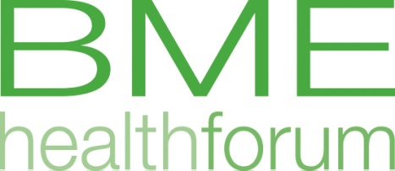

March Quarterly Meeting 2018

Date: Wednesday 27th March 1.30-4.30
Venue: Irish Cultural Centre, 5 Black's Rd, Hammersmith, London W6 9DT

Programme

1.30-2.00 Lunch

2.00-2.30 Bethany Golding from Hammersmith & Fulham CCG will discuss the financial recovery plans and ask for feedback from BME communities’ perspective

2.30-3.15 Anne Pollock and Andrew Carpenter from Westminster Council and RBKC will seek feedback about the Dementia Strategy

3.15-3.30 Break

3.30-3.40 Minutes and Actions from the last meeting.

3.40-4.05 Updates from Groups and organisations –an opportunity for attendees to update others about work in their organisation.

4.05-4.20 Rayaa Ali from the Iraqi Association will present the organisation and how they support the Iraqi community.

4.20-4.30 Alex Silverstein from the Diabetes Transformation team will update us on the World Foods Carbs and Cals book (specifically targeted at BAME communities)

All welcome. A hot lunch will be available at 1.30 pm.

