Digital Inclusion the guidelines notes
How to use AbilityNet’s tool
My Computer, My Way
to make your device easier to use
1. On the internet, go to mcmw.abilitynet.org.uk or search for My Computer My Way
2. Use the filters to narrow results by:
Category (Cognitive, Motor, Vision)
Adjustment (Mouse settings, Zoom/Magnify, Voice Input etc)
Condition (Dyslexia, MS, Visual Impairment, Hearing Impaired etc)
Symptom (Blurred vision, Hearing loss, Poor grip etc)
Operating System (Defaults to Windows 10, has options for Android, Mac, Windows etc)
- Once you select a help topic, it will show you a short guide version and a have a longer (step by step) version below that.

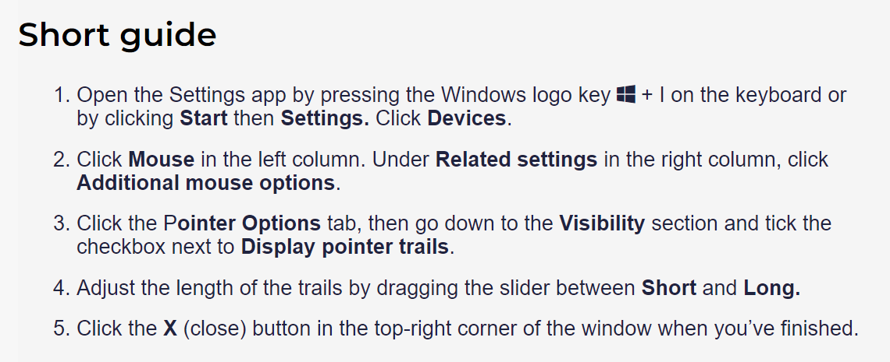

If you are using a screen reader then I would recommend using the Shell version (https://accessibility.shell.com/mcmw)

It has a simple pathway to the topics.
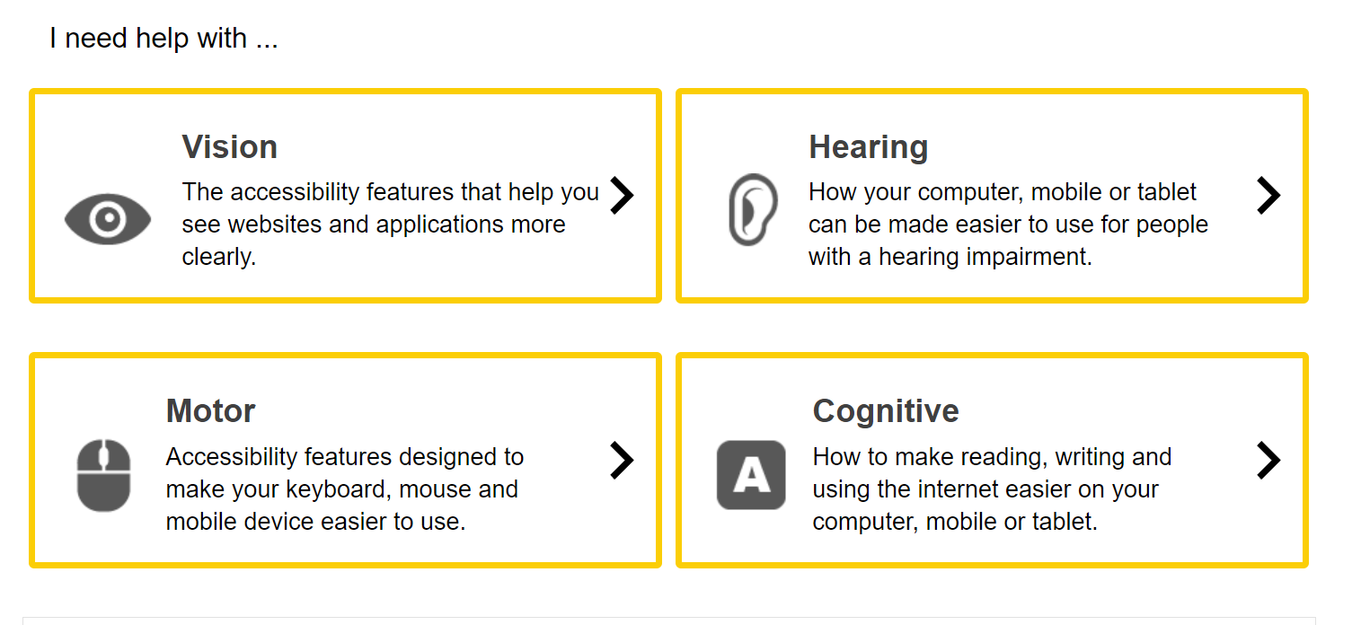
Training:
https://abilitynet.org.uk/free-tech-support-and-info/digital-skills-training-people-over-65?utm_source=Website0&utm_medium=BTDigitalSkillsFormJan24&utm_campaign=Website-banner (or search for Free Tech Support AbilityNet)
AbilityNet and telecommunications company BT Group are working in partnership to help improve the digital skills of older and digitally excluded people across the UK during 2023 and beyond.
Are you an organisation, charity or individual 65 years old or over that could benefit from digital skills training?
AbilityNet's friendly team of Digital Skills trainers can provide free digital skills training to support older people (65+ years) in London.
Trainers can run the following sessions, or build something bespoke for your group or for an individual:
- An Introduction to Tech
- An Introduction to the Internet
- Getting to know your Smartphone or Tablet
- Staying Safer Online
- Getting started with Email
- Using Social Media, e.g. Facebook
- Online entertainment, e.g. watching TV online
- How to access Public Services e.g. Gov.UK
- Downloading Apps: Android
- Downloading Apps: Apple
- How to make a video call
- How to manage your health online
- How to bank online
- How to shop online
- Using a computer for documents

You can request a training session
Call our helpline on 0800 048 7642 (freephone) during UK office hours
Send an email to digitalskills@abilitynet.org.uk

Free tech support & information for disabled and older people
How to get free help from our tech volunteers
We have a network of more than 350 friendly tech volunteers who can help you or someone you are supporting. They can come to your home, or help you on the phone.
Volunteers are all DBS-checked and are happy to deal with any tech problems you may be having, large or small.
To request help from tech volunteers just call us on 0300 180 0028 during UK office hours, or email us at enquiries@abilitynet.org.uk

