Grenfell Community Support
Brief for the community activities pilot

Context for the community activities pilot
In January 2025, the council launched the Grenfell Community Support, a programme for residents who live within 500m of Grenfell Tower or lived there at the time of the tragedy.
The support is for 4 years starting in January 2025 and includes:
- A household wellbeing grant for people who lived in the area at the time of the tragedy
- A free Kensington Leisure centre membership
- The support of a community advocacy team; and
- A programme of community activities
The programme of community activities has not yet been launched. However, we heard extensive feedback through the original consultation in 2023/24 and through the recent review of the programme in 2025 about what kind of activities the community want to see.
In order to deliver something quickly, we have agreed with the Operational Steering Group (OSG) that we will launch a 4-month pilot in order to have a temporary offer in place between April and July while the work on the long-term community activities design takes place.
The budget for the pilot is £40k and the pilot will comprise a suite of projects especially designed to support individuals and families eligible for the Grenfell Community Support. Individual projects will have to address one of the three priorities below:
- Enhance residents' wellbeing
- Provide opportunities for group day trips
- Provide opportunities for creative activities
These reflect the main priorities of residents who gave feedback through the review.
The selection process will have to ensure that the pilot provides a balance of activities that collectively will meet all three priorities.
The applications will be reviewed by Council officers to check they meet the criteria and then by Notting Dale councillors who will decide on successful projects.
The deadline for sending your completed application is the 3 March. However, we strongly encourage you to send your application by 26 February, so we can get back to you and ask for additional information if required. We will take two weeks to review all applications and will let you know if your project is selected by mid-March.
This document provides information about the type of projects we are looking for, the eligibility criteria for applicants and the process that we will use to select the projects to be included in the pilot. Alongside this document, applicants should also consult:
- The application form to be completed for each project and sent back to us
- The grant terms and conditions that your organisation will be required to sign if your project is successful
- The Grenfell Community Support Resident Handbook for information about the programme, including the eligibility and area of support.

Who can apply?
Applicants must be a constituted group with a bank account in the organisation’s name and two unrelated people able to sign cheques or other payments.
Applicants can be any of the following:
- charity
- community interest company
- residents’ association
- faith group
- voluntary and community sector (VCS) organisation

Applicants will have to demonstrate:
- They have an understanding of the immediate community and Grenfell impact, and have strong connections with the community
- They have a successful experience of delivering similar projects
- They will bring impact and value for local people, e.g. through enhancing residents’ wellbeing, improving community cohesion or employing local people

Applicants will be required to have the following documents in place, where applicable:
- safeguarding, health and safety and data protection policies
- relevant Disclosure and Barring Services checks (standard, enhanced or enhanced with barred list) for all staff and volunteers
- risk assessment for funded projects or events
- licences (temporary events notice or other relevant licence) and permissions for use of land and property
- employers’ liability insurance in accordance with the Employers' Liability (Compulsory Insurance Act) 1969 with a limit of indemnity of not less than £5,000,000 per claim or series of claims arising out of any one incident
- public liability insurance with a limit of indemnity of not less than £5,000,000 per claim or series of claims arising from one event
- professional indemnity liability insurance with a limit of indemnity of not less than £2,000,000 per claim or series of claims arising from one event

What type of projects are we looking for?
The pilot will include a mix of projects with a balance between group activities and those delivered as one to ones, and will collectively address the three agreed priorities.
All projects (except group day trips) will have to be delivered in Notting Dale.
These projects will have to:
- Meet one of these priorities:
  - Wellness, relaxation and wellbeing activities
- Group day trips (in London or further afield)
- Creative activities (arts & crafts, cooking, gardening etc)
- Be delivered within April – July 2026 period
- Be free of charge for residents
- Be solely for individuals eligible for the Grenfell Community Support
- Be inclusive and culturally sensitive.

What can and cannot be funded
We can fund:
- staff fees linked to projects
- service fees, including trainers and catering
- volunteer expenses
- travel expenses, including coach hire
- venue hire
- purchase of materials and products required for the project
- food and non-alcoholic drinks

We cannot fund:
- private limited companies
- statutory services
- events and projects that promote religious interests and objectives or exclude people based on religion
- events and projects that promote political interests and objectives or exclude people based on politics
- purchase of alcohol
- core running costs, including staff salaries, organisation’s utility bills, ongoing premises rent
- any fees or costs that are deemed not to be relevant to the project
- illegal activity

How much can be applied for
The total budget for the pilot is £40k to be allocated to a suite of projects, with maximum amount to be applied for as follows:
- Up to £2,000 for a one-off project such as a day trip outside London
- Up to £5,000 for an ongoing project over 2-3 months

The funding has to be used to deliver a dedicated project that meets the objectives of this fund.

How will applications be evaluated
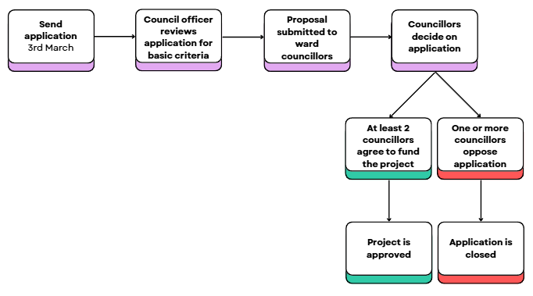
- All applicants must send an application form by the 3rd March and a bank statement from a bank account in the organisation's name that requires two unrelated people to sign cheques
- A council officer will review your application for basic criteria and will ask for additional information as required
- They will submit your answers and proposal to ward councillors who will decide on whether your application is successful.
- For a project to be approved, at least two councillors must agree to fund the project, and they may ask questions to make an informed decision. If one or more councillors oppose the application, it will be closed.
- A council officer will then email you to confirm if your application has been successful and to arrange payment of the grant.

Projects can be delivered over a shorter period within April - July
Projects will be promoted through the Council’s monthly Grenfell Community Newsletter

