Subject: London Arabic speaking support service for women affected by GBV, FM, FGM & HBV

Dear VAWG Coordinator,

We would like to remind you that DVIP’s Al-aman service has continued to receive funding from London Councils to support women from Arabic speaking communities who have been affected by gender based violence, forced marriage, female genital mutilation and honour based violence.

Al-aman, DVIP’s service for Arabic speaking communities has been supporting Arabic speaking women across London affected by all forms of gender based violence since 2000. The service is run by experienced bi-lingual staff from Arabic speaking countries with specialist knowledge of domestic abuse, forced marriage, female genital mutilation and honour crimes.

The Al-aman service offers women-centred support services by phone and individual meetings focussing on emotional support, safety planning and advocacy guidance. We also deliver a structured group work programme designed to empower and support women and provide them with practical skills to rebuild and retake control of their own and their children’s lives.

We accept referrals from community, voluntary and statutory agencies as well as self referrals from women themselves. To refer someone to our service, please contact the Women’s Service team on:
Tel: 020 8563 2250
Email: al-aman@dvip.org

We would welcome the opportunity to attend your VAWG forum to present our services.

Please do not hesitate to contact us should you require further information.

Kind regards,

The Al-aman Team

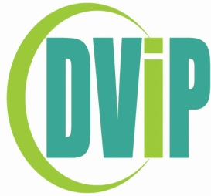

www.dvip.org www.londoncouncils.gov.uk/grants

