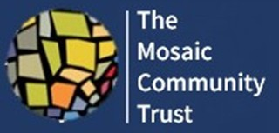

Information Sheet: Indian Head Massage Training For Mental Well-Being

6-Week Indian Head Massage Training Course for mental well-being

Focus: Improving mental health through therapeutic Indian Head Massage.

Start Date: 15 September 2025

Location: 12-18 Salisbury Street, Portman early childhood Centre NW8 8DE

Course Overview:
This free 6-week training course is designed to teach the techniques of Indian Head Massage, with a focus on improving mental well-being. Participants will gain practical skills, build confidence, and learn how massage therapy can support emotional and physical health.

What the Course Includes:
- Introduction to Indian Head Massage techniques
- Understanding the link between massage and mental health
- Guided hands-on practice each week
- Creation of a professional portfolio of case studies
- Final written and practical assessment
- Supportive learning environment with experienced trainers

Course Outcomes:
- Certificate of completion (subject to passing assessments)
- Practical experience to support others in your community
- Potential opportunity for paid work following the course

Entry Criteria:
To enroll, learners must:
- Have a good understanding of the English language (reading & writing)

- Commit to attending all 6 sessions
- Complete a portfolio of case studies by the end of the course
- Be willing to take part in a written and practical exam
- Reside in North Westminster

How to Apply:
To register your interest, please contact:

Email: habibahaque.mct@gmail.com
Phone: 07462561885
Web: www.mosaiccommunitytrust.org.uk

Places are limited - early registration is encouraged.

